THIS JOURNAL BELONGS TO:
____________________________________________________________________________________

EMERGENCY CONTACT:______________________________________________________________
RELATIONSHIP:______________________ PHONE #:______________________________________
ADDRESS:______________________________________________________________________________________________________________________________________________________________
EMERGENCY CONTACT:______________________________________________________________
RELATIONSHIP:______________________ PHONE #:______________________________________
ADDRESS:______________________________________________________________________________________________________________________________________________________________
DOCTOR:_______________________________ #___________________________________________
PSYCHIATRIST:__________________________________#___________________________________
THERAPIST:_____________________________#___________________________________________
MENTOR:_______________________________#___________________________________________
MEDICATIONS:______________________________________________________________________________________________________________________________________________________________________________________________________________________________________________________________________________________________________________________________________________________________________________________________________________________
DATE OF BIRTH: ______________________________BLOOD TYPE:__________________________
WOULD YOU BE IN CONCENT TO GETTING A BLOOD TRANSFUSION IF YOUR LIFE DEPENDED ON IT? YES NO
ANY ILLEGAL DRUG USE? YES NO IF SO WHICH KIND(S)?________________________________________________________________________________________________________________________________________________________________
ALCOHOL USE? YES NO SOMETIMES IF YES, HOW MUCH? ____________________________________________________________________________________
MARIJUANA USE? YES NO IF YES HOW OFTEN?__________________________
WHAT IS MY BIGGEST STRESSOR(S) RIGHT NOW? ____________________________________________________________________________________________________________________________________________________________________________________________________________________________________________________________
WHY DOES THAT CAUSE ME TO FEEL DIFFERENT? ________________________________________________________________________________________________________________________________________________________________________________________________________________________________________________________________________________________________________________________________________________
WHAT FEELING(S) DOES IT MAKE ME FEEL? ________________________________________________________________________________________________________________________________________________________________________
COULD I HAVE AVOIDED THE PERSON OR SITUATION? _________________________________
DID I HAVE ANY CONTROL OVER THE PERSON OR SITUATION? YES NO
A little sentence of great words: If you do not have any control over the person or situation, DO NOT worry over it, because you cannot change it!!! YES, easier said than done, I know, but as soon as you go by that rule, you will feel relief.

WHAT COPING SKILLS DID I USE? ________________________________________________________________________________________________________________________________________________________________________
DID ANY WORK? YES NO IF YES WHICH ONES? ________________________
________________________________________________________________________________________________________________________________________________________________________
Here are some coping skills to help you find one that will work for you. Remember coping skills are small little tactics you perform to calm you down. NOT RAMP YOU UP!!!
- Breathing exercises
- Counting something specific you see
- Art
- Sensory grounding techniques
- Sports
- Meditating
- Changing lifestyles
- Journaling
- Talking to someone you trust
- Music (not depressing music)
- Fidget toys
I used to laugh at my psych team when they told me to use my “coping skills”. Only because none worked that they gave me as examples, and I thought those were the only kind you can use for them to work. I thought I was broken because they did not work for me. Then my therapist asked me, what do you think would work for you to clear your mind and get back to a safe level. I knew right away what made me feel at peace; art, music, journaling and petting my Maine Coon, Fluffnut! You might have difficulty finding what makes you feel peaceful when you are all worked up, wait until you’re calm if that’s the case. If you want/need help now, go to your local emergency department or call 911. If you just want to talk to someone and have no one, call/text 988 and you will be connected to a local therapist. Or if you need resources dial 211.
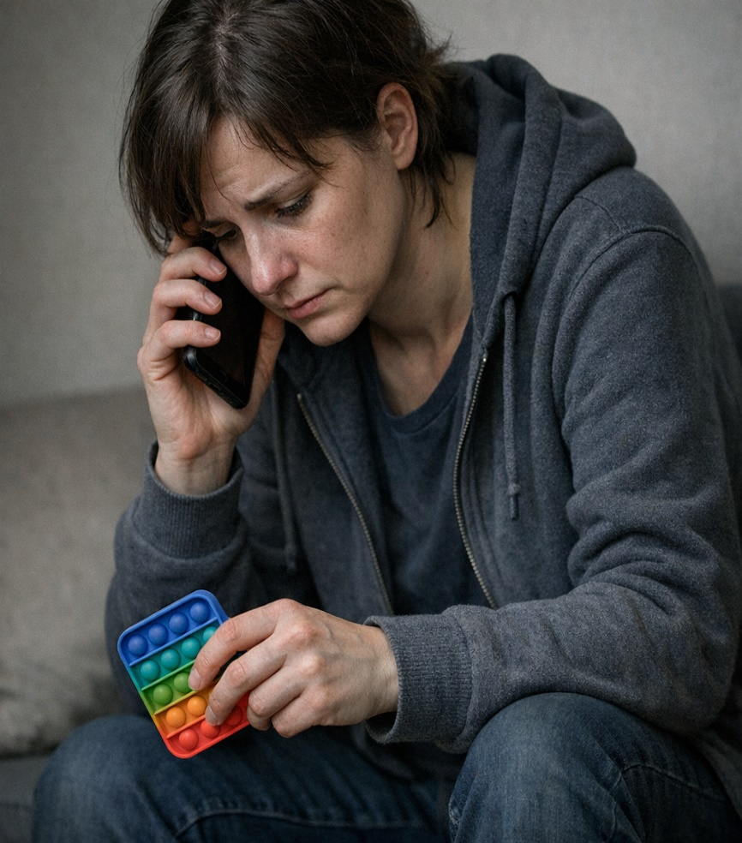

MONTH
___________________________________
YEAR
__________

SUNDAY | MONDAY | TUESDAY | WEDNESDAY | THURSDAY | FRIDAY | SATURDAY

DAILY CHECKIN
DAY ONE
STRESS LEVEL: 1 2 3 4 5 6 7 8 9 10 PAIN LEVEL: 1 2 3 4 5 6 7 8 9 10
ANXIETY LEVEL: 1 2 3 4 5 6 7 8 9 10 ANGER LEVEL: 1 2 3 4 5 6 7 8 9 10
DEPRESSION LEVEL: 1 2 3 4 5 6 7 8 9 10 PSYCHOSIS 1 2 3 4 5 6 7 8 9 10
DAY TWO
STRESS LEVEL: 1 2 3 4 5 6 7 8 9 10 PAIN LEVEL: 1 2 3 4 5 6 7 8 9 10
ANXIETY LEVEL: 1 2 3 4 5 6 7 8 9 10 ANGER LEVEL: 1 2 3 4 5 6 7 8 9 10
DEPRESSION LEVEL: 1 2 3 4 5 6 7 8 9 10 PSYCHOSIS 1 2 3 4 5 6 7 8 9 10
DAY THREE
STRESS LEVEL: 1 2 3 4 5 6 7 8 9 10 PAIN LEVEL: 1 2 3 4 5 6 7 8 9 10
ANXIETY LEVEL: 1 2 3 4 5 6 7 8 9 10 ANGER LEVEL: 1 2 3 4 5 6 7 8 9 10
DEPRESSION LEVEL: 1 2 3 4 5 6 7 8 9 10 PSYCHOSIS 1 2 3 4 5 6 7 8 9 10
DAY FOUR
STRESS LEVEL: 1 2 3 4 5 6 7 8 9 10 PAIN LEVEL: 1 2 3 4 5 6 7 8 9 10
ANXIETY LEVEL: 1 2 3 4 5 6 7 8 9 10 ANGER LEVEL: 1 2 3 4 5 6 7 8 9 10
DEPRESSION LEVEL: 1 2 3 4 5 6 7 8 9 10 PSYCHOSIS 1 2 3 4 5 6 7 8 9 10
DAY FIVE
STRESS LEVEL: 1 2 3 4 5 6 7 8 9 10 PAIN LEVEL: 1 2 3 4 5 6 7 8 9 10
ANXIETY LEVEL: 1 2 3 4 5 6 7 8 9 10 ANGER LEVEL: 1 2 3 4 5 6 7 8 9 10
DEPRESSION LEVEL: 1 2 3 4 5 6 7 8 9 10 PSYCHOSIS 1 2 3 4 5 6 7 8 9 10
DAY SIX
STRESS LEVEL: 1 2 3 4 5 6 7 8 9 10 PAIN LEVEL: 1 2 3 4 5 6 7 8 9 10
ANXIETY LEVEL: 1 2 3 4 5 6 7 8 9 10 ANGER LEVEL: 1 2 3 4 5 6 7 8 9 10
DEPRESSION LEVEL: 1 2 3 4 5 6 7 8 9 10 PSYCHOSIS 1 2 3 4 5 6 7 8 9 10
DAY SEVEN
STRESS LEVEL: 1 2 3 4 5 6 7 8 9 10 PAIN LEVEL: 1 2 3 4 5 6 7 8 9 10
ANXIETY LEVEL: 1 2 3 4 5 6 7 8 9 10 ANGER LEVEL: 1 2 3 4 5 6 7 8 9 10
DEPRESSION LEVEL: 1 2 3 4 5 6 7 8 9 10 PSYCHOSIS 1 2 3 4 5 6 7 8 9 10

Show this to your healthcare provider; it will help them better identify the main cause(s) and get you the help you need.
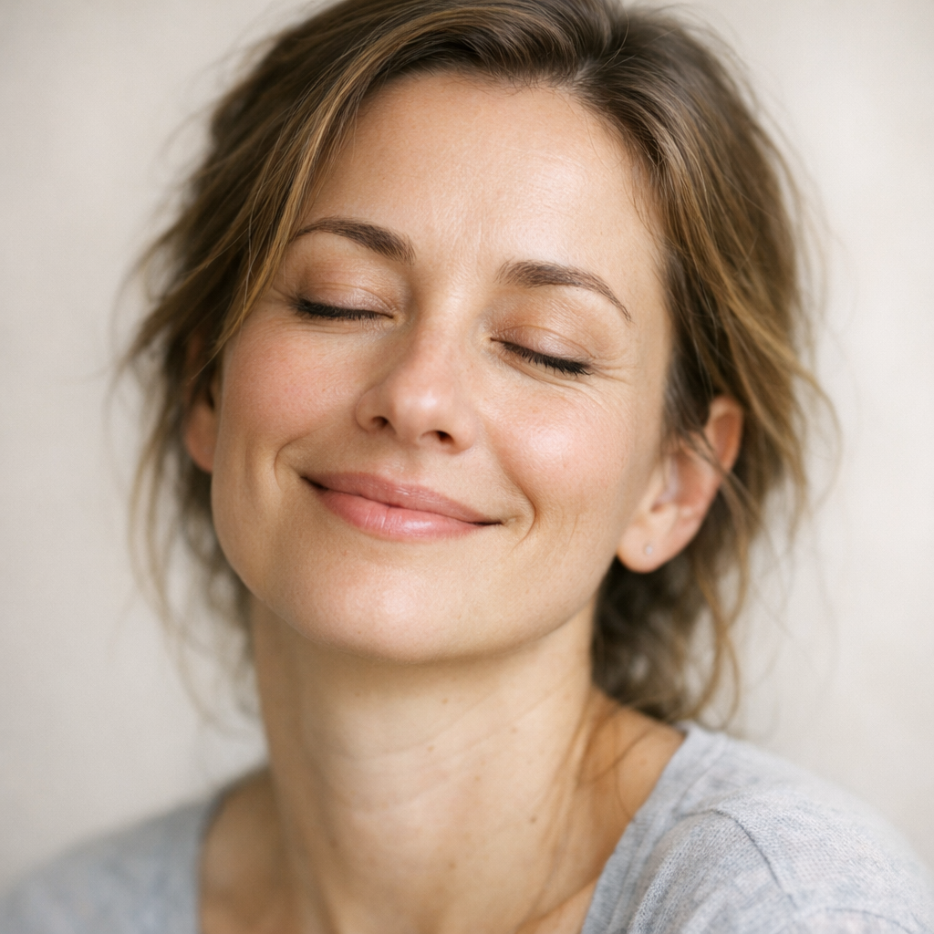
HOW DID I MANAGE MY SYMPTOMS? ________________________________________________________________________________________________________________________________________________________________________________________________________________________________________________________________________________________________________________________________________________________________________________________________________________________________________________________________________________________________________________________
HOW DID I NOT MANAGE MY SYMPTOMS? ________________________________________________________________________________________________________________________________________________________________________________________________________________________________________________________________________________________________________________________________________________
WHAT DID I DO TODAY? ____________________________________________________________________________________________________________________________________________________________________________________________________________________________________________________________________________________________________________________________________________________________________________________________________________________________________________________________________________________________________________________________________________________________________________________________________________________________________________________________________________________________________________________________________________________________________________________________________________________________________________________________________________________________________________________________________________________________________________________________________________________________________________________________________________________________________________________________________________________________________________________________________________________________________________________________________________________________________________________________________________________________________________________________________________________________________________________________________________________________________________________________________________________________________________________________________________________________________________________________________________________________________________________________________________________________________________________________________________________________________________________________________________________________________________________________________________________________________________________________________________________________________________________________________________________________________________________________________________________________________________________________________________________________________________________________________________________________________________________________________________________________________________________________________________________________________________________________________________________________________________________________________________________________________________________________________________________________________________________________________________________________________________________________________________________________________________________________________________________________________________________________________________________________________________________________________________________________________________________________________________________________________________________________________________________________________________________________________________________________________________________________________________________________________
WHAT DID I DO TODAY? ____________________________________________________________________________________________________________________________________________________________________________________________________________________________________________________________________________________________________________________________________________________________________________________________________________________________________________________________________________________________________________________________________________________________________________________________________________________________________________________________________________________________________________________________________________________________________________________________________________________________________________________________________________________________________________________________________________________________________________________________________________________________________________________________________________________________________________________________________________________________________________________________________________________________________________________________________________________________________________________________________________________________________________________________________________________________________________________________________________________________________________________________________________________________________________________________________________________________________________________________________________________________________________________________________________________________________________________________________________________________________________________________________________________________________________________________________________________________________________________________________________________________________________________________________________________________________________________________________________________________________________________________________________________________________________________________________________________________________________________________________________________________________________________________________________________________________________________________________________________________________________________________________________________________________________________________________________________________________________________________________________________________________________________________________________________________________________________________________________________________________________________________________________________________________________________________________________________________________________________________________________________________________________________________________________________________________________________________________________________________________________________________________________________________________
WHAT DID I DO TODAY? ____________________________________________________________________________________________________________________________________________________________________________________________________________________________________________________________________________________________________________________________________________________________________________________________________________________________________________________________________________________________________________________________________________________________________________________________________________________________________________________________________________________________________________________________________________________________________________________________________________________________________________________________________________________________________________________________________________________________________________________________________________________________________________________________________________________________________________________________________________________________________________________________________________________________________________________________________________________________________________________________________________________________________________________________________________________________________________________________________________________________________________________________________________________________________________________________________________________________________________________________________________________________________________________________________________________________________________________________________________________________________________________________________________________________________________________________________________________________________________________________________________________________________________________________________________________________________________________________________________________________________________________________________________________________________________________________________________________________________________________________________________________________________________________________________________________________________________________________________________________________________________________________________________________________________________________________________________________________________________________________________________________________________________________________________________________________________________________________________________________________________________________________________________________________________________________________________________________________________________________________________________________________________________________________________________________________________________________________________________________________________________________________________________________________________
WHAT DID I DO TODAY? ____________________________________________________________________________________________________________________________________________________________________________________________________________________________________________________________________________________________________________________________________________________________________________________________________________________________________________________________________________________________________________________________________________________________________________________________________________________________________________________________________________________________________________________________________________________________________________________________________________________________________________________________________________________________________________________________________________________________________________________________________________________________________________________________________________________________________________________________________________________________________________________________________________________________________________________________________________________________________________________________________________________________________________________________________________________________________________________________________________________________________________________________________________________________________________________________________________________________________________________________________________________________________________________________________________________________________________________________________________________________________________________________________________________________________________________________________________________________________________________________________________________________________________________________________________________________________________________________________________________________________________________________________________________________________________________________________________________________________________________________________________________________________________________________________________________________________________________________________________________________________________________________________________________________________________________________________________________________________________________________________________________________________________________________________________________________________________________________________________________________________________________________________________________________________________________________________________________________________________________________________________________________________________________________________________________________________________________________________________________________________________________________________________________________________
WHAT DID I DO TODAY? ____________________________________________________________________________________________________________________________________________________________________________________________________________________________________________________________________________________________________________________________________________________________________________________________________________________________________________________________________________________________________________________________________________________________________________________________________________________________________________________________________________________________________________________________________________________________________________________________________________________________________________________________________________________________________________________________________________________________________________________________________________________________________________________________________________________________________________________________________________________________________________________________________________________________________________________________________________________________________________________________________________________________________________________________________________________________________________________________________________________________________________________________________________________________________________________________________________________________________________________________________________________________________________________________________________________________________________________________________________________________________________________________________________________________________________________________________________________________________________________________________________________________________________________________________________________________________________________________________________________________________________________________________________________________________________________________________________________________________________________________________________________________________________________________________________________________________________________________________________________________________________________________________________________________________________________________________________________________________________________________________________________________________________________________________________________________________________________________________________________________________________________________________________________________________________________________________________________________________________________________________________________________________________________________________________________________________________________________________________________________________________________________________________________________________
WHAT DID I DO TODAY? ____________________________________________________________________________________________________________________________________________________________________________________________________________________________________________________________________________________________________________________________________________________________________________________________________________________________________________________________________________________________________________________________________________________________________________________________________________________________________________________________________________________________________________________________________________________________________________________________________________________________________________________________________________________________________________________________________________________________________________________________________________________________________________________________________________________________________________________________________________________________________________________________________________________________________________________________________________________________________________________________________________________________________________________________________________________________________________________________________________________________________________________________________________________________________________________________________________________________________________________________________________________________________________________________________________________________________________________________________________________________________________________________________________________________________________________________________________________________________________________________________________________________________________________________________________________________________________________________________________________________________________________________________________________________________________________________________________________________________________________________________________________________________________________________________________________________________________________________________________________________________________________________________________________________________________________________________________________________________________________________________________________________________________________________________________________________________________________________________________________________________________________________________________________________________________________________________________________________________________________________________________________________________________________________________________________________________________________________________________________________________________________________________________________________________
WHAT DID I DO TODAY? ____________________________________________________________________________________________________________________________________________________________________________________________________________________________________________________________________________________________________________________________________________________________________________________________________________________________________________________________________________________________________________________________________________________________________________________________________________________________________________________________________________________________________________________________________________________________________________________________________________________________________________________________________________________________________________________________________________________________________________________________________________________________________________________________________________________________________________________________________________________________________________________________________________________________________________________________________________________________________________________________________________________________________________________________________________________________________________________________________________________________________________________________________________________________________________________________________________________________________________________________________________________________________________________________________________________________________________________________________________________________________________________________________________________________________________________________________________________________________________________________________________________________________________________________________________________________________________________________________________________________________________________________________________________________________________________________________________________________________________________________________________________________________________________________________________________________________________________________________________________________________________________________________________________________________________________________________________________________________________________________________________________________________________________________________________________________________________________________________________________________________________________________________________________________________________________________________________________________________________________________________________________________________________________________________________________________________________________________________________________________________________________________________________________________________
NOW THAT YOU’VE GONE A WEEK DOCUMENTING YOUR FEELINGS, YOUR STRESSORS, LEARNED SOME COPING SKILL AND WHAT HAPPENED THROUGHOUT THE WEEK, YOU HAVE THE START OF YOUR HEALING COMPLETED. CONGRADULATIONS! IF YOU NEED HELP DO NOT HESITATE TO GET IT, CALL 211 TO FIND A PSYCHIATRIST, THERAPIST OR GROUPS IN YOUR LOCAL AREA. THEY ALSO HAVE INFO ON LOCAL FOOD BANKS.

WHAT HAVE I LEARNED ABOUT MYSELF? ________________________________________________________________________________________________________________________________________________________________________________________________________________________________________________________________________________________________________________________________________________________________________________________________________________________________________________________________________________________________________________________________________________________________________________________________________________________________________________________________________________________________________________________________________________________________________________________________________________________________________________________________________________________________________________________________________________________________________________________________________________________________________________________________________________________________________________________________________________________________________________________________________________________________________________________________________________________________________________________________________________________________________________________________________________________________________________________________________________________________________________________________________________________________________________________________________________________________________________________________________________________________________________________________________________

BE PROUD OF YOURSELF, KNOWING YOUR SELF WORTH AND KNOWING YOU NEED HELP TO CLARIFY YOUR MIND. IN ORDER TO BE HEALTHY AND STAY HEALTHY IS FIRST TO HAVE A HEALTHY MIND. I KNOW I’M PROUD OF YOU!

AWARD
FOR
CLEARING MY
MIND
NAME:_____________________________________________________________________________
DATE:_________________________________TIME:________________________________________
TEACHER: myself

______________________________________
signature n date

COUPON:
DO SOMETHING NICE FOR MYSELF; BUY SOMETHING, VACATION, RELAX, GET A MASSAGE, GO TO THERAPY!

