DAILY PLANNER ________ _______. _______ ______ AM/PM
MONTH. DAY. YEAR. TIME
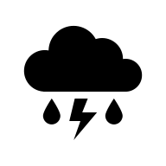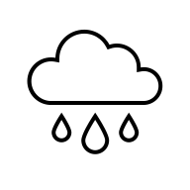
SCHEDULE
6:00AM _________________________________ TOP PRIORITIES
7:00AM _________________________________ 1._______________________________
8:00AM _________________________________ 2. _______________________________
9:00AM _________________________________ 3. _______________________________
10:00AM ________________________________ TO DO LIST
11:00AM ________________________________ 1. ______________________________________________________________________________O
12:00PM ________________________________ 2. ______________________________________________________________________________O
1:00PM _________________________________ 3. ______________________________________________________________________________O
2:00PM _________________________________ 4. ______________________________________________________________________________O
3:00PM _________________________________ 5. ______________________________________________________________________________O
4:00PM _________________________________ 6. ______________________________________________________________________________O
5:00PM _________________________________ 7. ______________________________________________________________________________O
6:00PM _________________________________ 8. ______________________________________________________________________________O
7:00PM _________________________________ 9. ______________________________________________________________________________O
8:00PM _________________________________ 10. _____________________________________________________________________________O
9:00PM _________________________________
I am grateful for… REMINDERS!!!
_____________________ SHOWERED YES NO
_____________________ TOOK MEDICATION YES NO
_____________________ I DRANK __ BOTTLES OR __ OUNCES
MOOD 1=DEPRESSED 10=EXCITED. OF WATER TODAY.
- 2 3 4 5 6 7 8 9 10

DAILY JOURNAL DATE: __________________TIME: _______AM/PM
DAILY GOALS TODAY’S SELF-CARE

DID I TAKE ANY SUBSTANCE I AM ADDICTED TO YES NO IF YES, WHAT _____________________________________________
IF NO, I AM SO PROUD OF YOU!! ANOTHER DAY CLEAN…KEEP GOING YOU CAN DO IT!!!

TODAY I AM THANKFUL FOR TODAY MY MOOD WAS
__________________________________________________ __________________________________________________________
__________________________________________________ __________________________________________________________
__________________________________________________ __________________________________________________________
__________________________________________________ __________________________________________________________
MY FAVORITE PART OF THE DAY WAS TODAY’S THOUGHTS
__________________________________________________ __________________________________________________________
__________________________________________________ __________________________________________________________
__________________________________________________ __________________________________________________________
__________________________________________________ __________________________________________________________
WHAT MADE TODAY STAND OUT WHAT CAN I DO TO HAVE A BETTER TOMORROW
__________________________________________________ __________________________________________________________
__________________________________________________ __________________________________________________________
__________________________________________________ __________________________________________________________
__________________________________________________ __________________________________________________________
DID I ATTEND AA OR NA? WHY/WHY NOT DO I HAVE A SPONSER? YES NO
__________________________________________________ NAME: ___________________________________________________
__________________________________________________ PHONE #: ________________________________________________
__________________________________________________ MEET ADDRESS: __________________________________________
__________________________________________________ IF NO…GET ONE!!!!!! TRY TO GET SAME GENDER AS YOU.

SELF REFLECT

DRAW OR WRITE; SOMETIMES WORDS ARE HARD TO FIND, OR VISUAL IS BETTER FOR YOU

________________________________________________________________________________________________________________________________________________________________________________________________________________________________________________________________________________________________________________________________________________________________________________________________________________________________________________________________________________________________________________________________________________________________________________________________________________________________________________________________________________________________________________________________________________________________________________________________________________________________________________________________________________________________________________________________________________________________________________________________________________________________________________________________________________________________________________________________________________________________________________________________________________________________________________________________________________________________________________________________________________________________________________________________________________________________________________________________________________________________________________________________________________________________________________________________________________________________________________________________________________________________________________________________________________________________________________________________________________________________________________________________________________________________________________________________________________________________________________________________________________________________________________________________________________________________________________________________________________________________________________________________________________________________________________________________________________________________________________________
FOOD DIARY. DATE: _____/______/_______
MEALTIME AND DESCRIPTION
 | BREAKFAST | AM SNACK | LUNCH | NOON SNACK | DINNER | PM SNACK
TIME
CALORIES
PORTION
DESCRIPTION
FRUITS VEGGIES
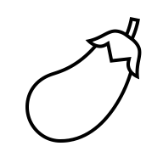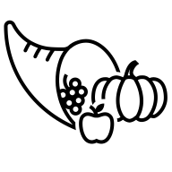
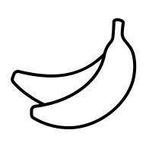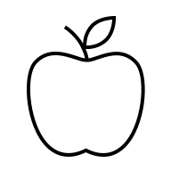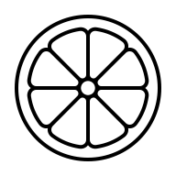

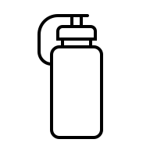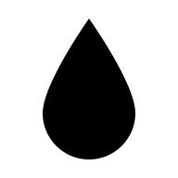
WATER

FEELINGS BEFORE EATING FEELINGS AFTER EATING
(E.G. HAPPY, SAD, MAD, ANXIOUS) (E.G. GUILTY, ENERGETIC, TIRED)

HUNGER 1-10 BEFORE EATING _______ FULLNESS 1-10 AFTER EATING ______
NUTRITION REFLECTION | YES | NO
DID YOU INCLUDE A BALANCE OF PROTEIN, CARBOHYDRATES, AND HEALTHY FATS?
DID YOU CONSUME ENOUGH FRUITS AND VEGETABLES?
DID YOU DRINK ENOUGH WATER?

WHAT WENT WELL TODAY WITH YOUR WHAT COULD BE IMPROVED?
EATING HABITS? ___________________________________
______________________________________________________________________ ___________________________________
DIRECTIONS TO FOOD DIARY
FILL OUT THE CORRECT DATE AND DOCUMENT THE TIME YOU ATE, WRITE IN HOW MANY CALORIES CONSUMED (DO NOT GUESS), FOR PORTION DO YOUR BEST TO WEIGH IN OUNCES (EVERYBODYS DEFINITIONS OF S,M,L AND XL ARE ALL DIFFERENT), AND DESCRIPTION, JUST BASICALLY WRITE WHAT YOU ATE.

